Return Distribution Analysis, Microsoft & Apple
Project by
Meaghan Ryan

Saint Mary’s University’s Sobey School of Business

May 2026, Halifax, Nova Scotia

Date: May 10th, 2026

Project Introduction:
This project examines the distributional behaviour of Microsoft monthly prices and returns, along with Apple daily price and return movements. The analysis applies core financial analytics techniques including outlier assessments, Winsorization, descriptive statistics, distribution fitting, and visual return analysis. Microsoft prices are evaluated for skewness and outlier influence, while Microsoft retuns are assessed as a more appropriate representation for risk and forecasting. Apple’s January 2020 price and return patterns are also used to demonstrate how time-series plots and return histograms can support interpretation of market movement, volatility, and financial behaviour. Together, the project shows how statistical diagnostics can transform raw market data into practical financial insight for investment analysis and decision-making.

1.) Due to its extreme values, the raw data in the Microsoft (MSFT) monthly prices exhibit right skewness. In order to assess the influence of the outliers, Winsorization is used to reduce the influence of the extremes. The data was Winsorized at the 1% and 5% levels, both with replacement (i.e., capping at the percentile thresholds) and without replacement (truncating). Descriptive statistics for all four scenarios were compared. The 1st and 99th percentiles are preferred because it limits outlier impact without distorting the distribution. We have valuable data, and 5% Winsorization applies stronger adjustment that is too aggressive in its data replacement. I choose 1% Winsorization to ensure my data is still valuable and telling enough to allow for potential identifiable correlations. The results for all four scenarios are displayed in Figure I (a).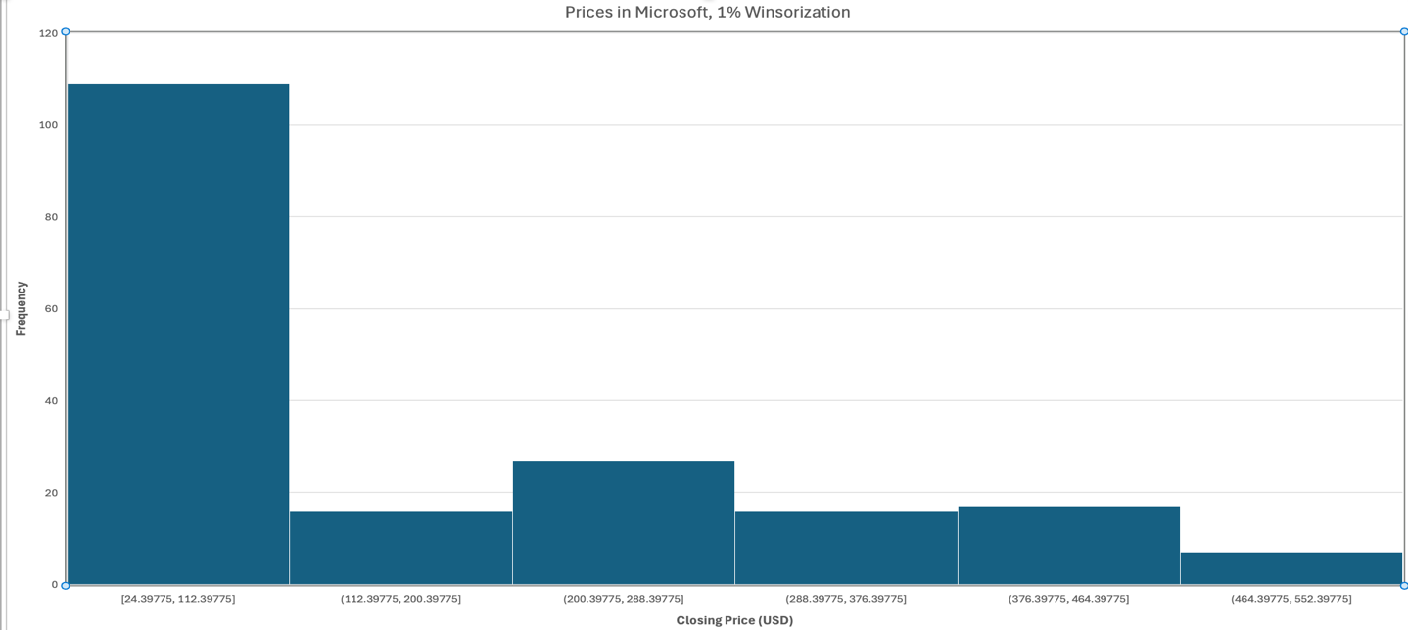
Figure I (a). Distribution of Microsoft Inc. (MSFT) monthly closing prices with 1% Winsorization, illustrating the presence of extreme values and right-skewness in the raw monthly price data.
2.) Using the MSFT monthly closing price series, I compute monthly simple returns as: R_{t} = (P_{t} — P_{t-1})/P_{t-1}. Then I summarize the distribution of monthly simple returns using descriptive statistics (mean, median, standard deviation, minimum, maximum, and skewness). The monthly return is centred close to zero, and is approximately symmetric, which is typical equity return behaviour. For this reason, and because returns are already much less skewed than prices, additional Winsorization of returns is not necessary.
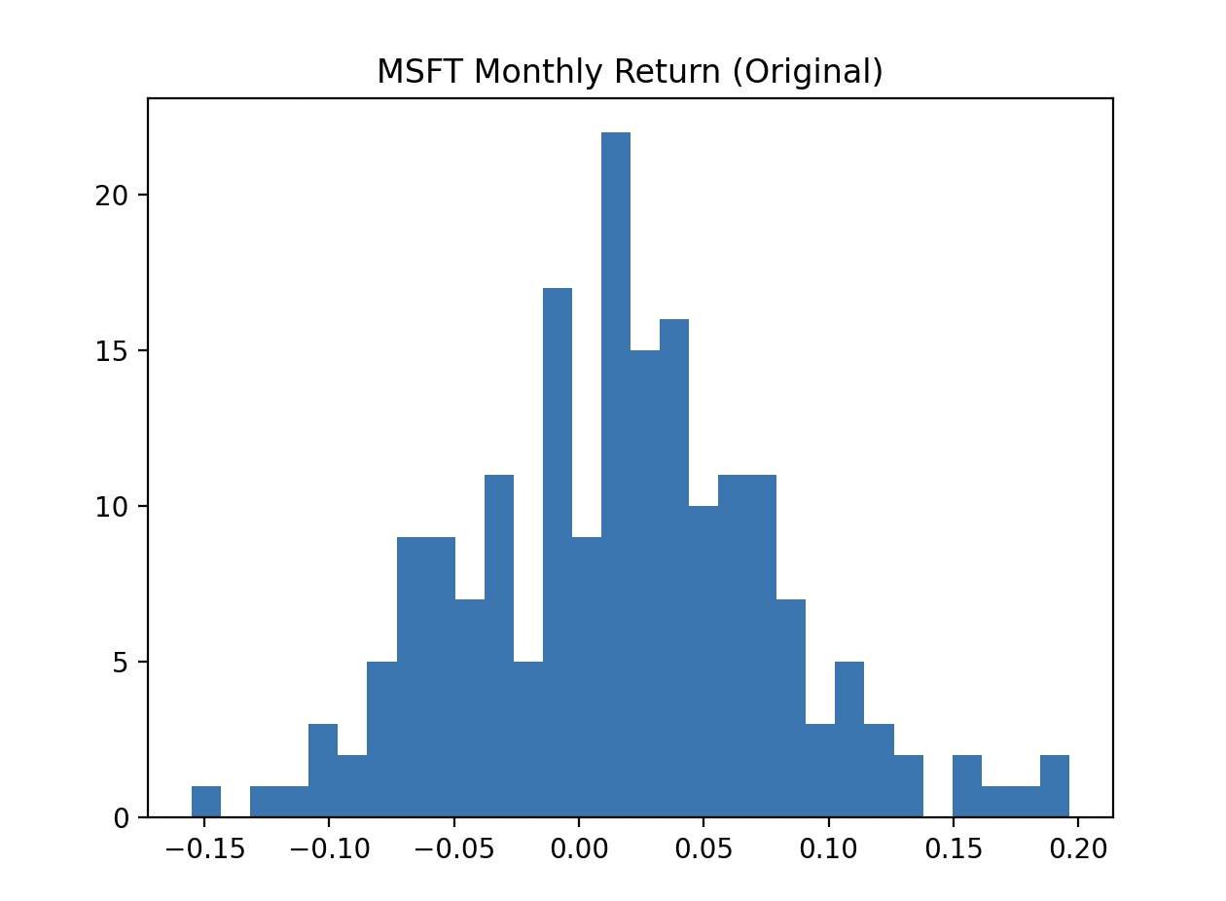
Figure I (b). Distribution of Microsoft Inc. (MSFT) monthly returns (original), illustrating approximate symmetry around zero. This is prior to doing Winsorization.
3.) This section identifies the probability distributions which reasonably describe MSFT’s monthly stock price and monthly return data based on statistical analysis. Because MSFT’s monthly prices are strictly positive and exhibit right-skewness, monthly prices are well modeled by a Lognormal distribution. The fitted Lognormal density captures the positive support and asymmetric shape observed in the data.
In contrast, MSFT’s monthly returns are centred near zero and display approximate symmetry with comparable left and right tails. As shown by the fitted density, the Normal distribution provides a reasonable description of monthly returns. The estimated Normal parameters for monthly returns are μ = 0.016887 and σ = 0.062087, indicating a small positive average return and moderate dispersion. Model comparison using Akaike Information Criterion (AIC) further supports specification over a Student-t alternative for monthly returns as the normal model yields a lower AIC. This behaviour is to be expected, given the approximately symmetrical shape observed in the monthly return (Figure I (c)).
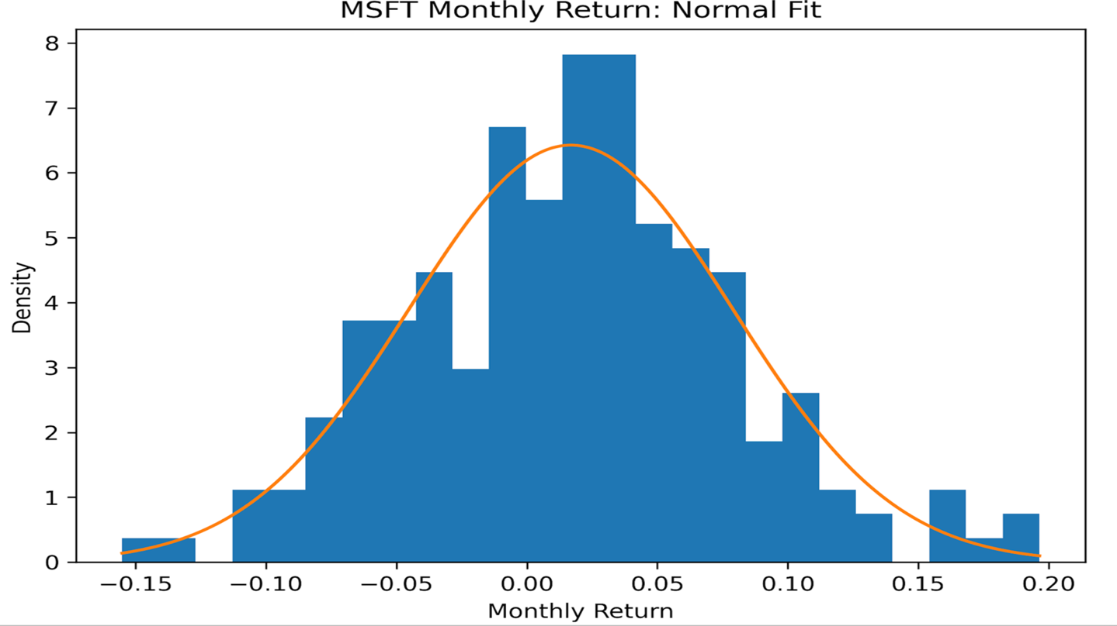
Figure I (c). Distribution of Microsoft (MSFT) monthly returns with fitted Normal density. The histogram shows returns centred near zero with approximate symmetry and comparable left and right tails. The overlaid Normal distribution, parameterized by the estimated mean (μ) and standard deviation (σ), provides a reasonable description of empirical return distribution and is preferred to a Student-t alternative based on Akaike Information Criterion (AIC).
4.) Because monthly prices are strictly positive and display right-skewness, a Lognormal model is appropriate. A key diagnostic is that if P is Lognormal, then ln(P) should be approximately Normal. Figure I (d) shows the histogram of ln (MSFT monthly price) with an overlaid fitted Normal density. The distribution s reasonably bell-shaped, supporting the Lognormal specification for monthly prices. The implied Normal parameters for ln(price) are the fitted mean μ_{ln P} and standard deviation σ_{ln P} estimated from the data.

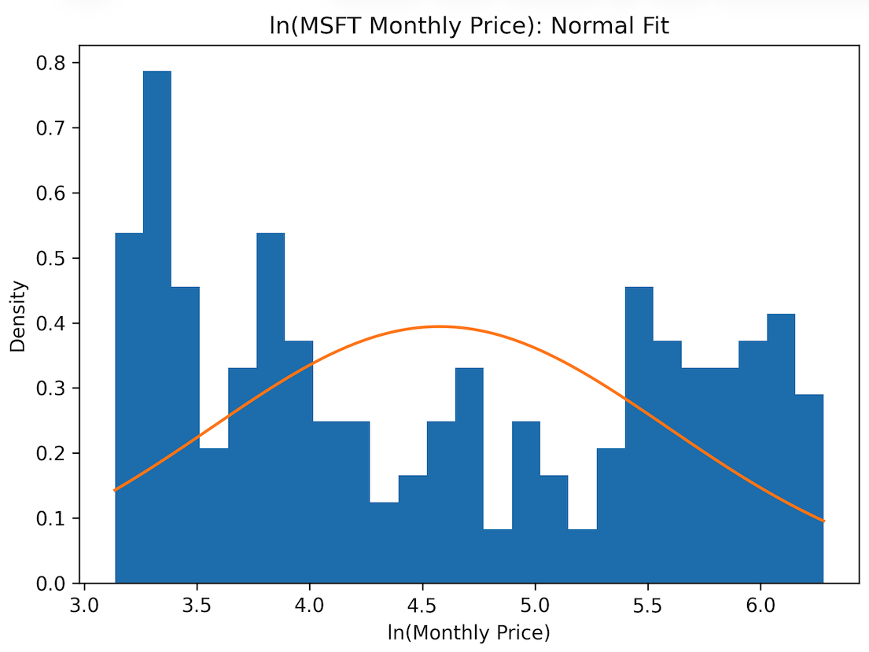
Figure I (d). ln(MSFT Monthly Price), Normal Fit.
5.) To do the diagnostic, prescriptive, and analytics in finance, I think the most suitable data representation is generally the return series rather than the price level because returns directly capture the changes and risk relevant to forecasting. For most forecasting and prescriptive tasks focused on performance and risk returns, return are the most appropriate primary input.

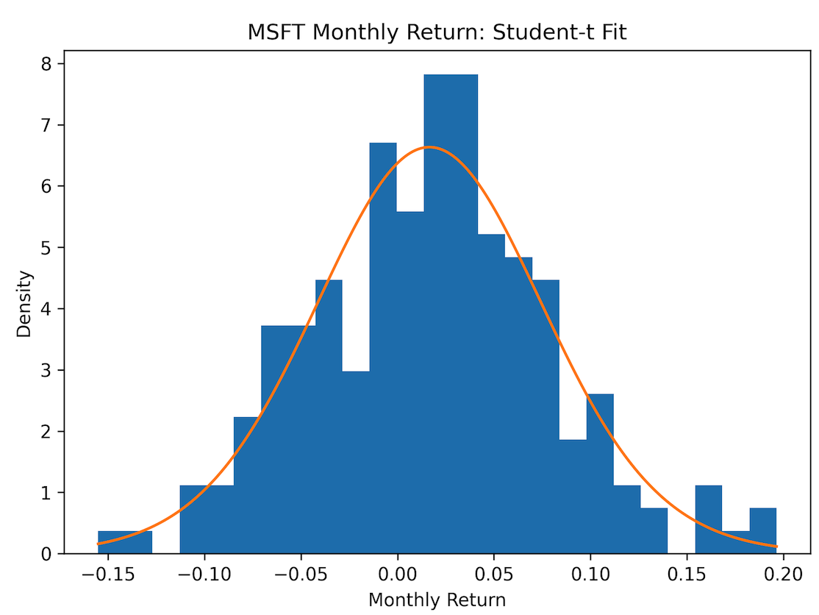
Figure I (e) displays the MSFT Monthly Return, Student-t Fit.
- 1.) This section presents the daily adjusted closing price of Apple Inc. throughout January 2020. The time series plot in Figure II (a) provides a clear visual summary of price dynamics throughout the month. After a brief decline in the first five trading days, AAPL had an upward movement beginning around January 9th, which indicates a period of positive market momentum. Although there are minor fluctuations present toward the end of the month, the overall pattern reflects a general increase in price levels across the January trading period.
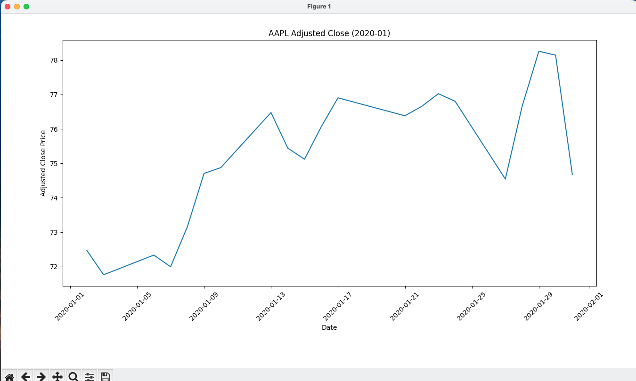
Figure II (a). Daily adjusted closing price of Apple Inc (AAPL) during January 2020.

2.) This figure highlights the frequency of typical daily price movements relative to more extreme observations. You’ll notice a high concentration of returns near zero which indicates that most daily changes in AAPL’s prices were modest, while the gradually thin tails reflect the presence of less frequent, larger price movements. Figure II (b) presents a histogram of daily returns, providing insight into how returns are distributed around their central tendency (per the Central Limit Theorem). Its distribution shape highlights the frequency of typical daily movements relative to more extreme observations. This gives a useful perspective on return variability and market behaviour in January 2020. It allows for an assessment of volatility, so one can glean the likelihood of larger price-changes in comparison to routine fluctuations.
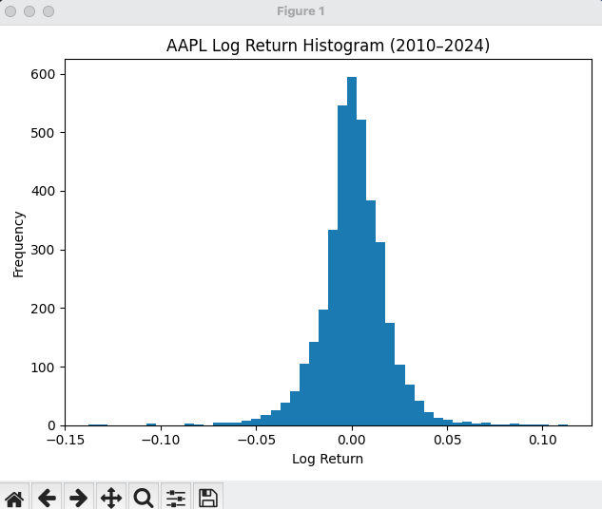
Figure II (b). Histogram of daily logarithmic returns for Apple Inc. (AAPL), which illustrates the distribution of returns and overall volatility characteristics.

- The conversation with Chat GPT 5.2 Thinking Model can be read at this link. This includes all the generated output from AI, and all prompts, per your instruction in Part III:

- I instructed the model to identify outliers in Microsoft prices and/or returns, per Part III subsection A. It was then instructed to discuss Winsorizations, covering these questions:

- Why is Winsorization needed?
What Winsorization level is best (e.g., 1%, 5%)?
Does the Winsorization meaningfully change the data?
- When prompted to review distributional analysis, it made observations similar to mine with no significant or problematic differences. The wording was a bit different as it referred to a “slightly heavy tail” whereas I use the terms “thick/thin” or “fat” tail per what I was taught in lectures. Data and calculations were consistent with my observations and commentary. It generated some histograms, also consistent with mine.

Note: It was vague in its initial response; I prompted it to elaborate on what Winsorization was appropriate in its opinion. When prompted, the chosen Winsorization level was the same as mine, which was 1% for reasons similar to mine. It commented about 5% being “aggressive”.

- Chat GPT didn’t make any remarkable mistakes, to my knowledge. They correctly interpreted financial concepts and made proper statistical analysis. In terms of limitations of the data, I think the data is limited, being monthly, but with that frequency you can miss cool/valuable trends such as when the stock was unusually risky or volatile. It’s also a bit vague to make any confident determination of when extreme movements happened. Chat GPT didn’t seem to think so or at least didn’t comment on it.

